 | JOIN US!  When you join OPAC you are supporting advocacy for recreational access and maintenance on public lands.  To join OPAC, complete this application, sign the liability release and agreement (all members 18 and over), and enclose payment:  - Individual (Yearly) $25.00  - Organizational (Yearly) $100.00  - Mail to: OPAC, PO Box 544, Montesano, WA 98563 |  |  |  |  |  |  |  |  |  |  |  |  |  |  | 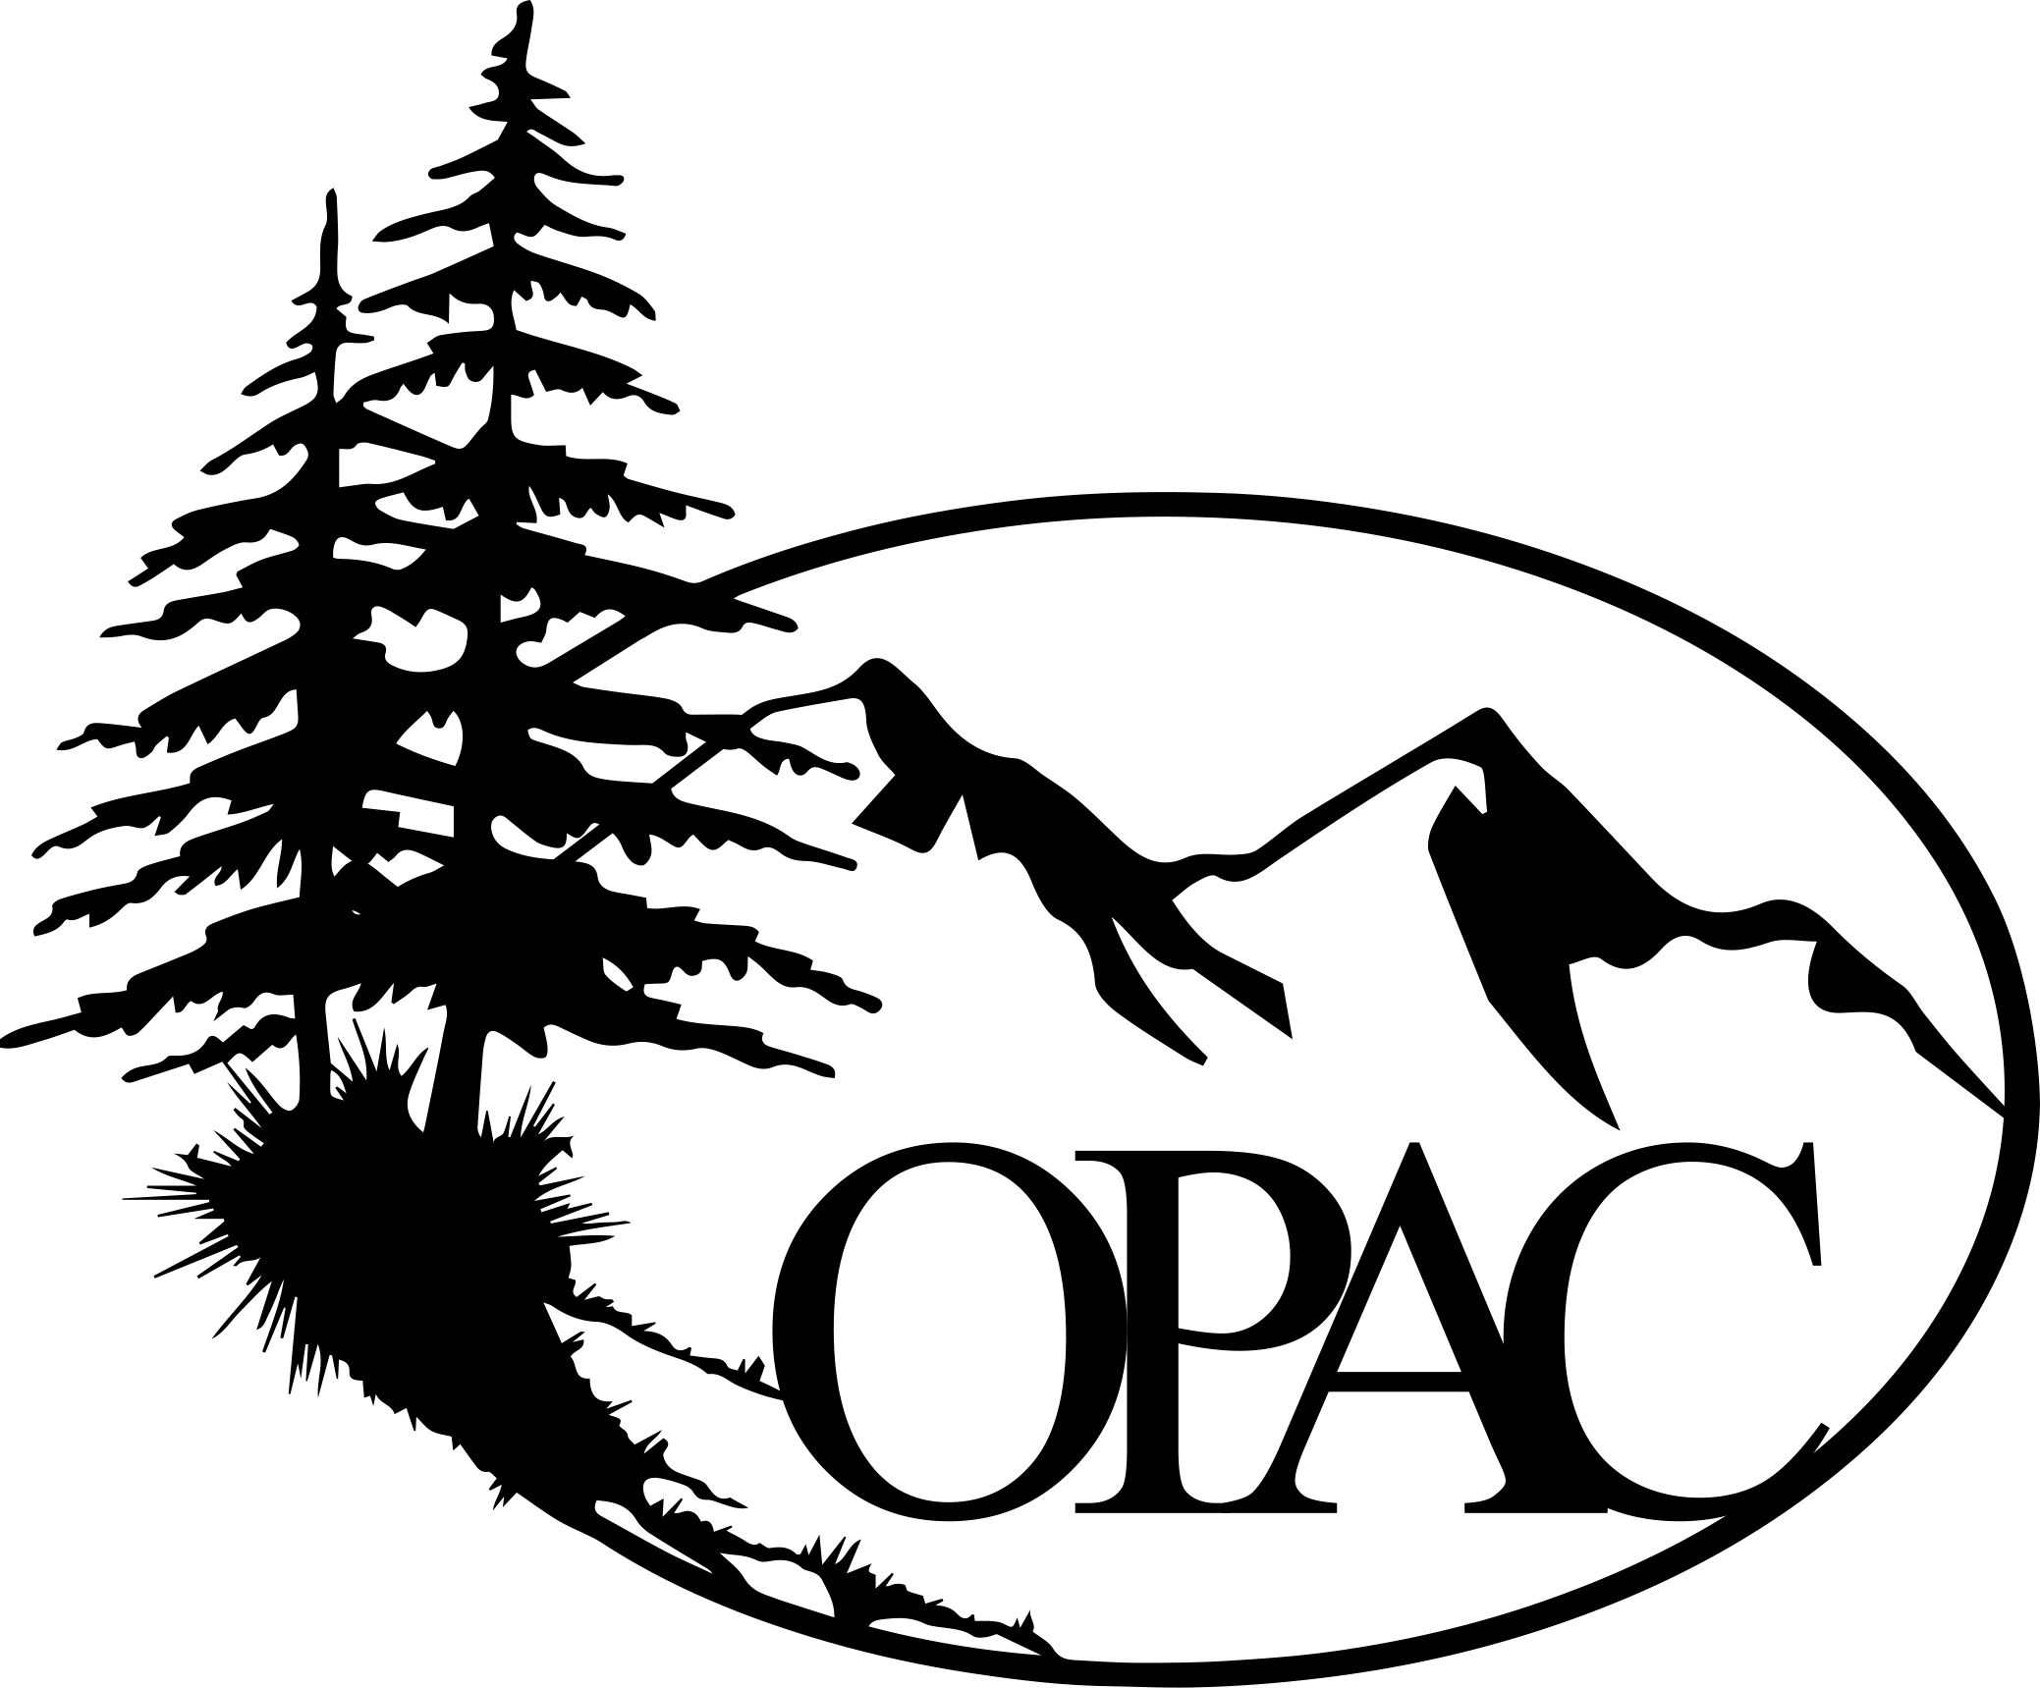
 | Membership Information:
 | New Member Renewal
 | Name:
 | Mailing Address:
 | City: |  |  |  |  |  |  |  |  |  |  |  |  | ST: |  |  |  | Zip:
 | Phone number: |  |  |  |  |  |  |  | E-mail:
 | MEMBERSHIPS:
 | Basic Membership
 |  |  | Single |  |  |  |  | $25.00
 |  |  | Organizational |  |  |  |  | $100.00
All ADULT members MUST sign! Adult’s signature covers minor children.
Recognizing the fact that there is a potential for an accident whenever a person is in the backwoods or on a trail, which can cause injuries to participants and spectators, and also recognizing the fact that OPAC, including officers, directors, or members, cannot always know the condition of trails or the experience levels of participants of OPAC events, I do hereby hold harmless the above named from any claim or right for damages which might occur to me or my minor children.

ARTICLE II Section II of Bylaws:
Purpose – 1) To unite multi user groups and individuals dedicated to maintaining and expanding recreational public access. 2) To develop productive working relationships with public and private landholders, always being mindful of trust, respect, and commitment as foundation blocks. To encourage, support, and at times contribute to projects, plans, and ideas for: recreational public access, healthy forests, clean watersheds, and wildlife habitat. 3) To educate and inform the public in issues related to recreational public access, conservation, volunteering, and stewardship. 4) To support timber harvest as an economical means of sustaining local communities. To support applications of vegetation management for forest health, wildlife habitat, and reducing forest density as a method of fire suppression.
By signing this application, I agree to the Purpose of OPAC as stated in Article II Section II of the Bylaws (above) and to receive notices from OPAC by electronic transmission at the above email address.
 | Signature: |  |  |  |  |  |  |  |  |  |  |  |  |  |  |  | Date:
 | Olympic Public Access Coalition (OPAC) a nonprofit entity, powered by volunteers. THANK YOU! ☺

